


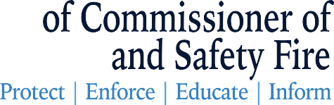

Rule Change Reducing Prelicensing Course Hours

A Rule change to prelicensing course hours requirements was published on July 29, 2025. This change reduced the required hours from 20.0 hours to 8.0 hours per major lines. The major lines are identified as:

Life;
Accident and Sickness;
Property;
Casualty; and
Personal Lines.

Limited Subagent courses must contain a minimum of 8.0 hours per combination line of Life, Accident and Sickness or Property and Casualty.

We cannot change the hours for already approved courses due to issues with course completions to licensees' records that have already been uploaded. New courses can be submitted at your convenience. If you wish to inactivate any courses, you can handle that process via email at ce_providers@pearson.com. Be sure to include the licensing state (Georgia), course name and id along with your provider ID.

While there is a change to the course hours requirements, the licensing knowledge requirements are not changing. These outlines are provided in the Georgia Insurance Licensing Candidate Handbook on the OCI website.

All renewals will continue for all approved courses regardless of hours. Also, as a reminder, renewal invoices for education providers are available at www.sircon.com as of August 1, 2025, with a due date of October 1, 2025. Please verify your contact information is correct and up to date to ensure seamless communication. This information can be updated when submitting the provider renewal. If you experience any issues with updating this information, please email the contact changes to ce_providers@pearson.com and include the licensing state (Georgia) and provider ID in the email.

