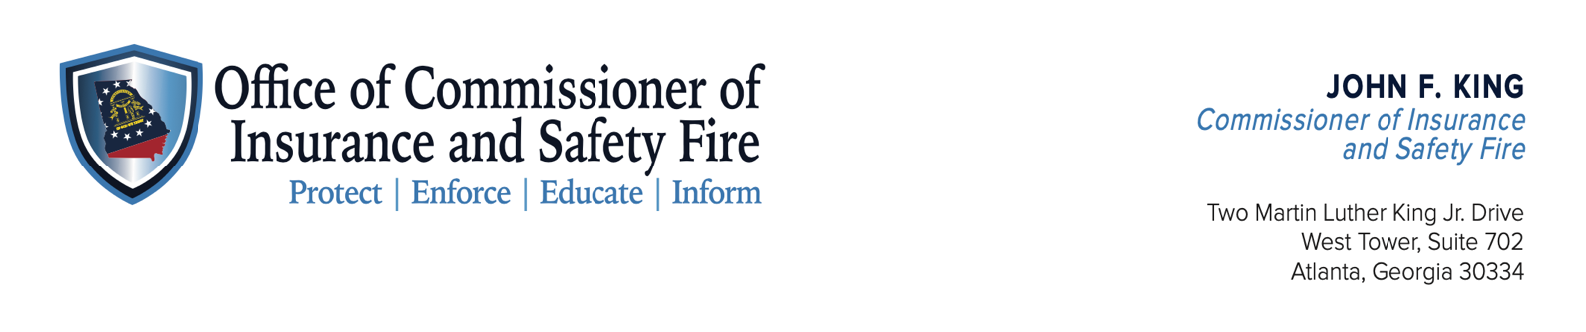
NEWS RELEASE

Twitter: @GA_DOI
Facebook: @GeorgiaDOI
Instagram: @GeorgiaDOI
For Immediate Release
July 22, 2022
Contact: Weston Burleson, 404-232-1388

COMMISSIONER KING ASKS FOR HELP IDENTIFYING VEHICLE INVOLVED IN JESUP ARSON INVESTIGATION

ATLANTA – Insurance and Safety Fire Commissioner John F. King is asking for help identifying the owner of a vehicle involved in a Jesup Arson Investigation.

At approximately 3:25 a.m. on Saturday, July 9th, a vehicle was seen driving past an active fire inside of the Harris Real Estate building. The vehicle is believed to be a 2019-2021 Toyota Rav 4, either gray or silver in color.

“The vehicle is seen driving slowly by 141 East Cherry Street a total of three times before leaving the scene,” said Commissioner King. “We are asking anyone with information on the owner of this vehicle to contact the Georgia Arson Control Board at 1-800-282-5804.”

###
The mission of the Office of the Insurance and Safety Fire Commissioner is to protect Georgia families by providing access to vital insurance products and safe buildings through fair regulation that creates economic opportunities for all Georgians.

