**FINGERPRINTING REGISTRATION PROCESS FOR INSURANCE APPLICANTS**

**Office of Commissioner of Insurance and Safety Fire (OCI)**

**GAPS Service Code - 2TGJ6B**

All resident and DHS applicants **must apply for an Insurance License prior** to registering for fingerprinting. You can apply online at [www.sircon.com](https://www.sircon.com).

Summary of the steps to complete fingerprinting

* Applicants apply for the insurance license
* Complete the Enrollment & Fingerprinting at GAPS
* OCI will review the fingerprinting request and verify an application has been submitted
* Once the registration is approved in GAPS, the applicant will receive an email to access the GAPS system to schedule an appointment
* Applicant will schedule the appointment and pay the fee
* Applicant will get fingerprinted at the location and time scheduled
* Fingerprint report will be reviewed by OCI

Step by step guide to the fingerprinting process.

1. After submitting your application for the insurance license desired, access GAPS at ga.state.identogo.com/ata

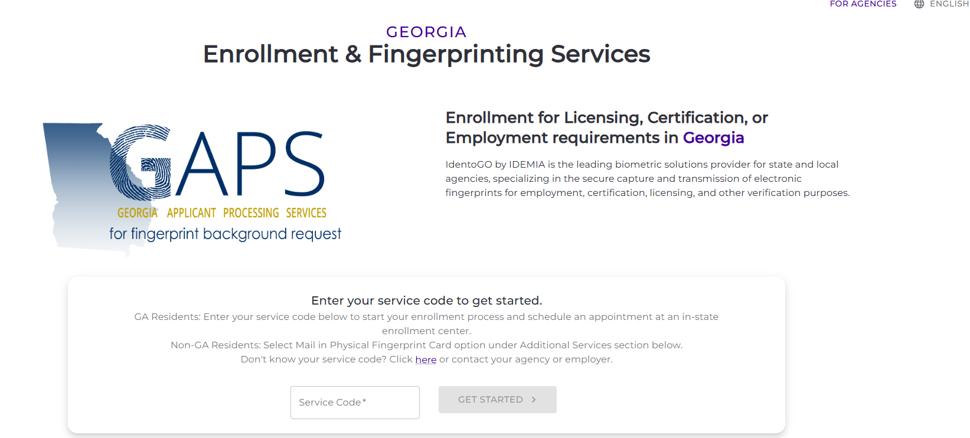

1. Enter OCI’s Service Code in the box – 2TGJ6B. The system will not let you move forward without entering the Service Code
   1. Click on Get Started to begin registering
2. The next screen displays the name of the State Agency that you selected by entering the Service Code. If you have been provided a Requesting Agency number, enter it on this screen. If you have not been provided this number by an insurance company or agency that you are working with, you can click Continue to move to the next screen.

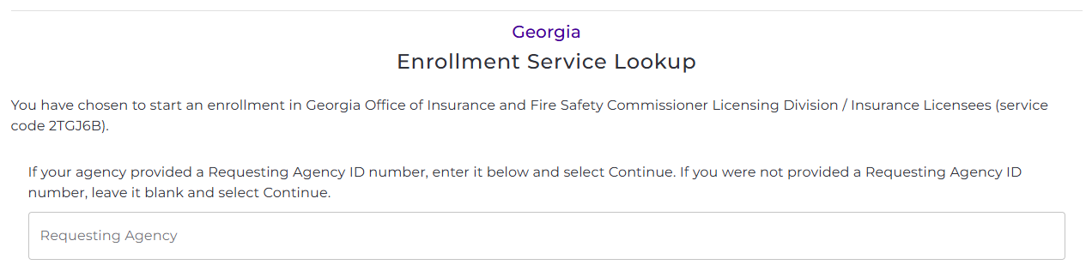

1. The next screen confirms the information you have entered.
   1. If there is any information that is not correct, click on BACK at the lower right of the screen to continue.
   2. If the information is correct, click on START ENTROLLMENT at the lower right of the screen to continue.

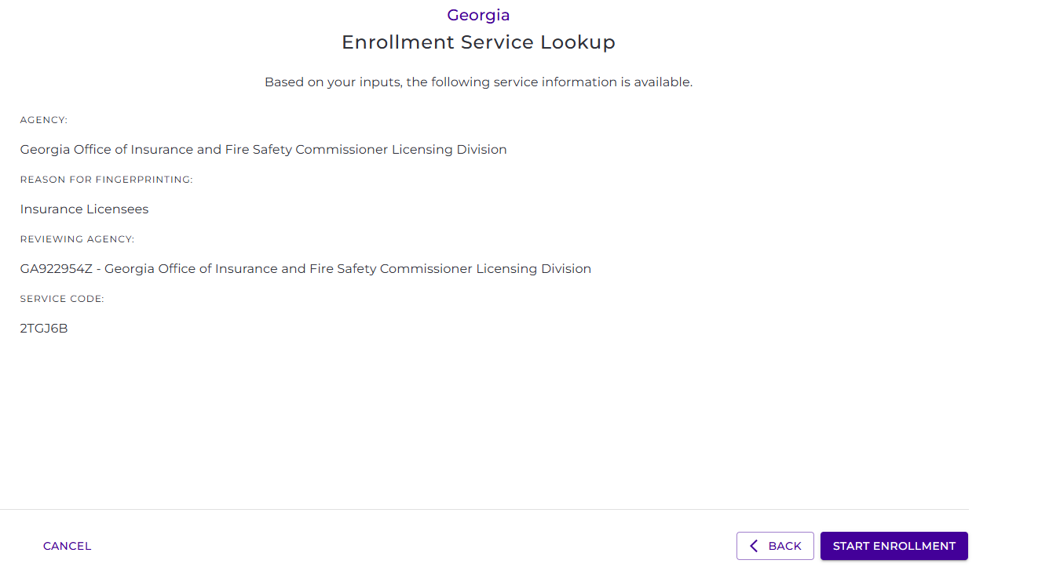

1. The next screen should be read and agreed to be able to agree to the fingerprinting process.
   1. After reading, click on the box to acknowledge that you read, understand and agree to the Statement and click on Continue. You can click on DOWNLOAD to keep a copy of the Statement.
   2. If you do not agree to this Statement, you will click on CANCEL ENROLLMENT at the lower left of the screen.

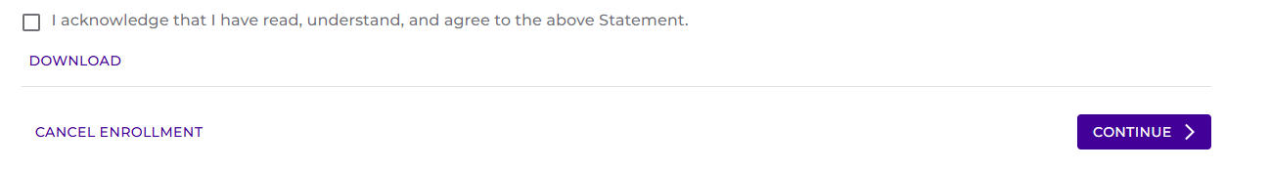

1. The next screen is to be completed with your personal information. All fields that contain an asterisk (*) are required. **OCI requires the Social Security Number to be provided** even though the system does not require it. If you do not provide a full SSN and we cannot locate your application, the enrollment request will be denied, and you will be required to request again.
   1. The contact information entered should be the email and phone number you use and have access. Emails are sent to the email address provided with information on approval/denials/scheduling of appointments.
   2. If you determine you do not wish to enroll, click on CANCEL ENROLLMENT at the lower left of the screen.
   3. After reviewing your entries for accuracy, click on REVIEW to move forward.
   4. If any required information is missing, the screen will not move forward and a message in red will populate for review and corrections.

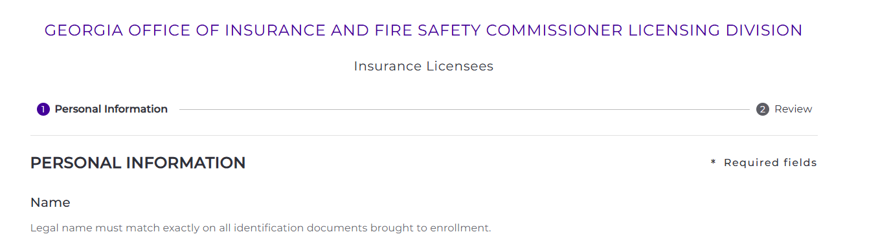

1. At this screen, you will review the information provided,
   1. If information needs to be corrected, click on BACK at the lower right of the screen
   2. If information is correct, click on SUBMIT ENROLLMENT at the lower right of the screen
   3. If you wish to cancel your enrollment request, click on CANCEL ENROLLMENT at the lower left of the screen

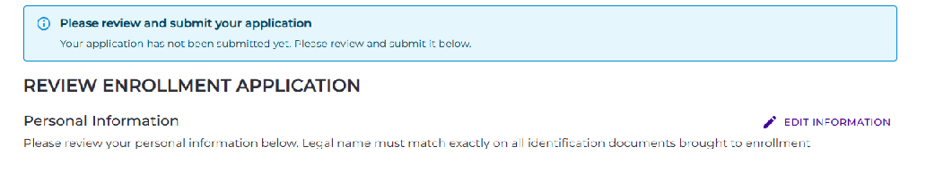

1. The next screen will confirm your submission. Instructions will be provided via email to the email address provided to schedule your appointment or if there was an issue with your request.
2. Check your email account over the next business day for instructions. OCI reviews fingerprint enrollment requests daily on business days (Monday through Friday).
3. When the approval email is received, note the UEID number provided, you will need this number when access GAPS again to schedule your appointment. This approval is good for 90 days. After 90 days, you will need to reregister.
   1. Access GAPS at ga.state.identogo.com/ata
   2. Scroll down the screen to the Reschedule or Manage Appoint icon
   3. DO NOT SELECT Mail-In Physical Fingerprint Card unless you are a DHS applicant and have prior approval from OCI. All that do not meet this requirement will be rejected by OCI.

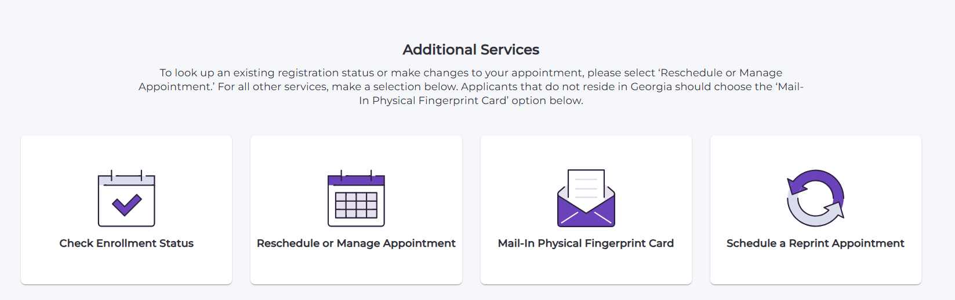

1. A pop-up will appear. You can search by any of the fields provided. The UEID is required to be provided. Click CONTINUE
2. The screen will appear to Schedule Appointment by entering a city, state and/or zip code. Change the distance from that location if desired. Click on Search.
3. From the list provided, select the location
   1. Dates and Times available will populate. You can select to sort by Show closest or Show soonest available by clicking on the radio button.
   2. Select the date and time preferred
   3. A Confirm Appointment box will appear
      1. Click on Back if other times are needed
      2. Click on Confirm if the date and time are accepted
      3. A final Confirm Appointment box will appear, click on NO, CANCEL to go back or YES, CONFIRM to accept.
4. A final summary page will appear providing all information for your appointment. You can click on BACK to start over or if as expected, click on CONTINUE TO PAYMENT at the right of the screen.
5. The payment screen offers payment by Credit Card or eCheck. Provide all information in the required fields and click on PAY AND SUBMIT.
   1. If you have been provided a Payment Code from a company or agency paying for your fingerprinting, enter the Code in the box at the right of the screen and click on Apply.
6. The final enrollment and payment screen appears. You can print this page or download a copy of the information by using the buttons on the lower left. You will also receive an email with this information.
7. Go to your fingerprinting location at the day and time selected.

NOTE: Please bring one of the listed identification documents to your appointment. Identification must be valid, not expired, and contain a photograph of the applicant.

* Driver's License issued by a State or outlying possession of the U.S.
* Driver's License PERMIT issued by a State or outlying possession of the U.S.
* Driver's License PAPER/TEMPORARY issued by a State or outlying possession of the U.S. Enhanced Driver’s License (EDL)
* Commercial Driver's License issued by a State or outlying possession of the U.S.
* Commercial Driver's License PERMIT issued by a State or outlying possession of the U.S
* ID card issued by a federal, state, or local government agency or by a Territory of the United States
* Enhanced Tribal Identification Card (for federally recognized U.S. tribes)
* Department of Defense Common Access Card
* Uniformed Services Identification Card (Form DD-1172-2)
* U.S. Military Identification Card
* U.S. Coastguard Merchant Mariner Card
* Military Dependent's Identification Card
* U.S. Passport
* Foreign passport ✓ Permanent Resident Card or Alien Registration Receipt Card (Form I-551)
* Employment Authorization Card/Document (I-766) that contains a photograph
* Canadian Driver's License
* Foreign Driver's License (Mexico and Canada Only)
* U.S. Visa issued by the U.S. Department of Consular Affairs for travel to or within, or residence within, the United States

1. If your prints are rejected, you will receive an email with instructions on how to be fingerprinted again. You must reprint within 30 days of the email. If rejected again, you will need to contact the GBI at 404-244-2639; Option 2 (M-F from 9am to 4pm).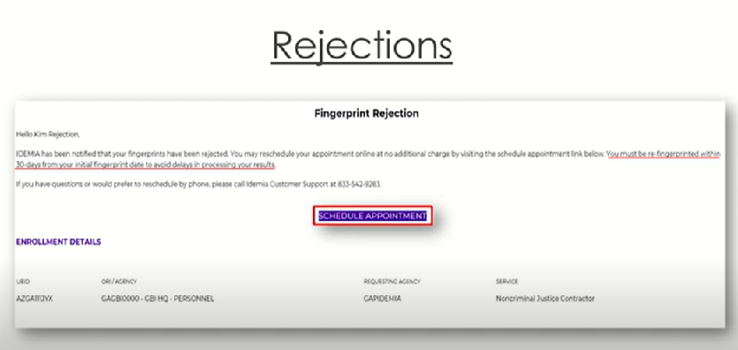
2. When OCI receives your report if any additional information is needed, you will be contacted via the email in your license application. Please allow at least three business days from the day you are fingerprinted for processing by OCI of your fingerprint report review.
3. If you have any questions regarding your fingerprinting enrollment, registration or need to change your appointment, access GAPS at ga.state.identogo.com/ata and scroll to the Additional Services icons for assistance. You can contact Idemia Customer Support regarding any fingerprinting communications or issues or GBI – GAPS office regarding GAPS.

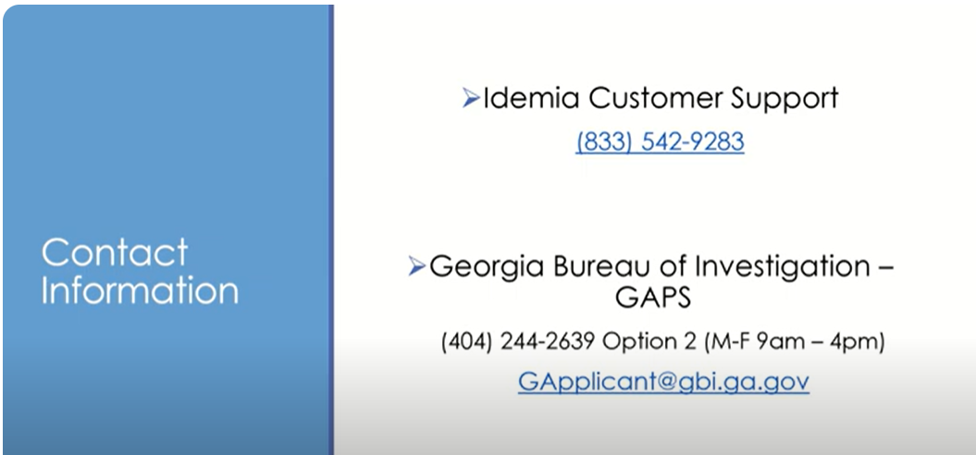

1. All registrations with payments that have not been used within 90 days will be refunded. These refunds will be credited back to the original payment method. If you do not receive the refund or have any questions regarding refunds, please contact GBI-GAPS listed above. Only this GBI-GAPS handle refunds.
2. For a status of your insurance license application with OCI, contact our back-office processing vendor, Pearson VUE by calling 800-274-8969 or by email at [pvgainsurance@pearson.com](mailto:pvgainsurance@pearson.com).